Here’s a comprehensive introduction and roadmap to Docker, starting from the basics to advanced concepts to help you become an expert in Docker:

🐳 What is Docker?
Docker is an open-source platform that allows you to:
- Package applications into containers — lightweight, standalone units that include everything needed to run the application.
- Run those containers consistently across any environment, from development to production.
Why use Docker?
- Eliminates "it works on my machine" problems
- Faster deployments and rollbacks
- Scales easily in cloud and DevOps pipelines

🧱 Docker Core Concepts
Concept | Description
Container | A lightweight, isolated environment to run applications
Image | A blueprint for creating containers (like a snapshot of an app + environment)
Dockerfile | Script used to build Docker images
Docker Hub | Registry of Docker images (public or private)
Volume | Persistent storage mechanism for containers
Network | Allows containers to communicate internally or externally
Docker Engine | The runtime that builds and runs containers
Orchestration | Management of containers at scale (e.g. Docker Swarm, Kubernetes)

🗺️ Docker Roadmap – Beginner to Expert
🔹 1. Docker Basics
- What is Docker?
- Installing Docker (Windows, macOS, Linux)
- Docker architecture (client-server, daemon, REST API)
- Docker vs Virtual Machines
- Docker CLI commands (docker run, docker ps, docker exec, docker stop, etc.)
🔹 2. Working with Docker Images & Containers
- Pulling images from Docker Hub
- Creating and managing containers
- Understanding container lifecycle
- Committing changes to images
- Tagging and pushing images to Docker Hub
🔹 3. Dockerfiles – Building Custom Images
- Writing a Dockerfile
- Common instructions: FROM, RUN, COPY, CMD, ENTRYPOINT, EXPOSE, ENV, WORKDIR
- Multi-stage builds
- Best practices for creating optimized images
🔹 4. Volumes and Persistence
- Managing volumes: docker volume create, inspect, mount
- Bind mounts vs volumes
- Use cases (databases, logs)
🔹 5. Networking in Docker
- Docker default bridge network
- Creating custom networks
- host, none, overlay networks
- Communicating between containers
🔹 6. Docker Compose
- Writing a docker-compose.yml file
- Defining services, volumes, networks
- Using environment variables
- Scaling services
- docker-compose up/down/logs/exec
🔹 7. Docker Registry
- Docker Hub (official registry)
- Creating private Docker registry
- Using docker login, push, pull
- Image tagging & versioning strategies
🔹 8. Docker Security
- Container isolation
- Running containers with non-root users
- Docker security scanning tools (e.g., Docker Scout, Trivy)
- Best practices (secrets management, image hardening)
🔹 9. Docker in CI/CD Pipelines
- Using Docker in Jenkins/GitHub Actions
- Dockerized test environments
- Building images in CI
- Caching layers to speed up builds
🔹 10. Orchestration & Scaling (Advanced)
- Docker Swarm
  - Creating a swarm cluster
  - Deploying services with scaling
  - Rolling updates and rollback
- Kubernetes (Advanced topic)
  - Kubernetes vs Docker Swarm
  - Deployments, Pods, Services

🛠️ Tools & Ecosystem
Tool | Purpose
Docker Desktop | GUI for managing Docker
Docker Compose | Tool to define and run multi-container apps
Portainer | Web UI to manage Docker containers
Trivy | Container vulnerability scanner
Minikube / K3s | Lightweight Kubernetes for local development

📘 Best Courses & Resources
🔸 Free
- Docker — Full Course for Beginners (YouTube – freeCodeCamp)
- Docker Official Docs
- Play with Docker (labs)
🔸 Paid/Certifications
- [Docker Mastery Course – Udemy (by Bret Fisher)]
- [Kubernetes & Docker – Udemy]
- [Docker Certified Associate (DCA) Exam Preparation]

🧑‍💻 Final Tips to Master Docker
- Practice daily — create, run, and debug containers.
- Build your own images from Dockerfiles.
- Use Compose to deploy a multi-container app (e.g., Node.js + MongoDB).
- Explore real-world apps — WordPress, MySQL, Nginx.
- Dive into container orchestration (Swarm → Kubernetes).
- Contribute to open source Dockerized projects on GitHub.

Would you like a hands-on project list or a roadmap in PDF format for easy tracking?

Docker POCS
- Write a docker file for Java, NodeJS, Python, AngularJs
- Build a Docker image of app. Take any app source code example java, php app or nodejs app
- Docker Linking. Run two containers frontend and backend for example nodejs as frontend and mongodb as backend run Docker container by binding container port to custom host port

- Docker volume Management : Attach volume to a db Container. then run same container on another host with volume data mounted and check if data persist

- Volume mount- Delete mysql container and create new with previous data

- Dockercompose: Implement all above pocs with dockercompose also
- How to override CMD command
- Tag docker image and push it to dockerhub(private repo)
- Write Multistage docker file
- Set env variable using dockerfile as well as command line

- Deploy 3 tier application in docker container expose frontend to internet(on same and different machine)

- how many containers will create?
- Docker on windows/virtual box
- lifecycle of containers
- difference b/w docker vm and docker
- how many layers allowed in docker container
- Service discovery
Let’s go through these Docker concepts one by one in a simple way!

1. How Many Containers Will Be Created?
The number of containers depends on:
✅ The number of times you run docker run <image>
✅ The docker-compose file if you’re using Docker Compose
✅ The scaling options (docker-compose up --scale app=3 creates 3 instances of app)
If you run:
docker run -d nginx
docker run -d nginx
You will create two containers, each running Nginx separately.

2. Docker on Windows/VirtualBox
- Docker on Windows:
  - Uses WSL 2 (Windows Subsystem for Linux) for better performance
  - You can install Docker Desktop to manage containers easily
- Docker on VirtualBox:
  - If your system doesn't support WSL 2, you can run Docker inside a Linux VM on VirtualBox.
  - You install Docker Engine inside the VM.
Which one to choose?
✔ Use Docker on Windows if possible (WSL 2) for better speed.
✔ Use VirtualBox if you need to run Docker on a system that doesn't support WSL 2.

3. Lifecycle of a Docker Container
A Docker container has different stages:
1️⃣ Created → Container is created but not started
2️⃣ Running → Container is actively running
3️⃣ Paused → Temporarily stopped (docker pause)
4️⃣ Stopped (Exited) → Container stopped (docker stop)
5️⃣ Restarted → Container is restarted
6️⃣ Removed → Container deleted (docker rm)
You can list all containers (running and stopped) with:
docker ps -a

4. Difference Between Docker and Virtual Machine (VM)
Feature | Docker | Virtual Machine (VM)
Size | Lightweight (MBs) | Heavy (GBs)
Speed | Starts in seconds | Starts in minutes
Performance | Uses less RAM & CPU | Uses more resources
Isolation | Shares OS kernel | Each VM has its own OS
Best For | Running multiple lightweight apps | Running full OS environments
🚀 Docker is great for microservices and lightweight applications, while VMs are better for full OS environments.

5. How Many Layers Are Allowed in a Docker Container?
Each Docker image is built in layers. There is no fixed limit, but:
- Each RUN, COPY, or ADD in a Dockerfile creates a new layer.
- More layers = larger image size.
- Docker caches layers to make builds faster.
👉 Best practice: Minimize the number of layers by combining commands:
RUN apt-get update && apt-get install -y curl vim

6. Service Discovery
Service discovery helps containers find and communicate with each other automatically.
- In Docker Compose, services talk to each other by name:
- services:
- web:
- build: .
- database:
- image: mysql
👉 The web container can talk to database using mysql://database:3306.
- In Kubernetes, service discovery is handled by DNS-based discovery.
✅ Why is it useful?
- Containers can scale dynamically.
- Services can communicate easily without IP addresses.

Wrapping Up
1️⃣ You can create multiple containers based on how many times you run a command.
2️⃣ Docker on Windows (WSL 2) is better, but VirtualBox is an alternative.
3️⃣ Containers have a lifecycle from creation to removal.
4️⃣ Docker is faster and lightweight compared to VMs.
5️⃣ Docker images have multiple layers, and fewer layers mean better performance.
6️⃣ Service discovery helps containers talk to each other automatically.
Hope that helps! 🚀 Let me know if you need any details!
1.Write a docker file for Java, NodeJS, Python, AngularJs
----------For java application---------
1.mkdir java-docker-app
2.cd java-docker-app
3.nano HelloWorld.java
public class HelloWorld {
public static void main(String[] args) {
System.out.println("Hello, World from Docker first java application- rakhi!"); }}
4. nano Dockerfile
# Use OpenJDK as base image
FROM openjdk:17
# Set the working directory inside the container
WORKDIR /app
# Copy the Java source file to the container
COPY HelloWorld.java .
# Compile the Java program
RUN javac HelloWorld.java
# Command to run the Java application
CMD ["java", "HelloWorld"]
5. sudo docker build -t java-hello-world .
6. sudo docker run --rm java-hello-world
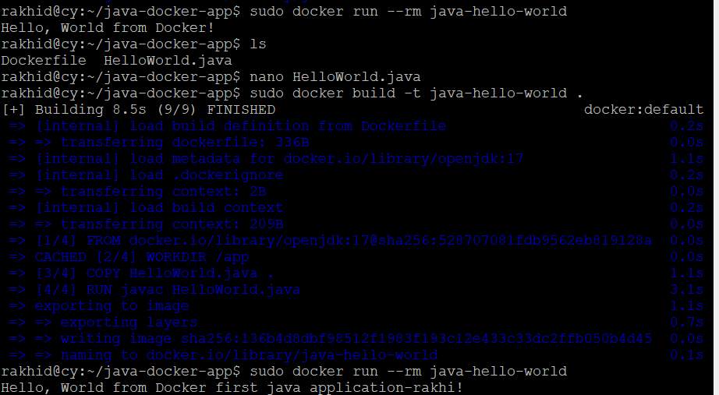
Multistage Dockerfile
# Stage 1: Build Stage
FROM openjdk:17 AS build
# Set the working directory inside the build stage
WORKDIR /app
# Copy the Java source file to the build stage
COPY HelloWorld.java .
# Compile the Java program
RUN javac HelloWorld.java
# Stage 2: Runtime Stage
FROM openjdk:17 AS runtime
# Set the working directory inside the runtime stage
WORKDIR /app
# Copy only the compiled class file from the build stage
COPY --from=build /app/HelloWorld.class .
# Command to run the Java application
CMD ["java", "HelloWorld"]
Sudo docker login
Login dockerhub credentials- username- rakhidhomane Password Radha@123
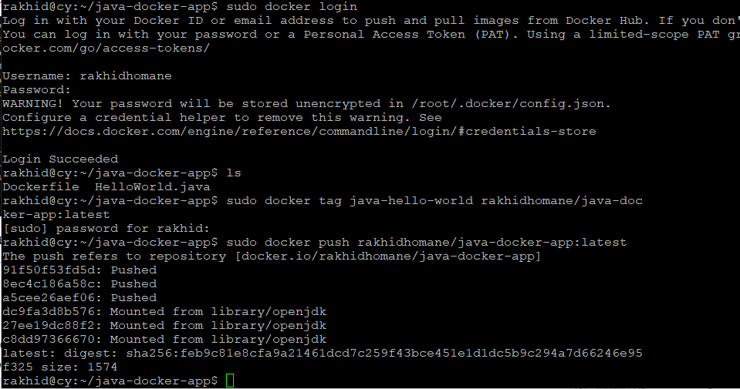

Steps to Push Docker Image to Docker Hub

1. Authenticate with Docker Hub
Log in to Docker Hub using your Docker Hub username and password:
sudo docker login
- Enter your Docker Hub username.- rakhidhomane
- Enter your password or access token (if you are using two-factor authentication).

2. Tag the Docker Image
Tag your Docker image with your Docker Hub repository name.
The format is:
sudo docker tag java-hello-world <dockerhub_username>/<repo_name>:<tag>
Example:
sudo docker tag java-hello-world rakhidhomane/java-docker-app:latest
- Replace <dockerhub_username> with your Docker Hub username (e.g., rakhidhomane).
- Replace <repo_name> with the name of your repository (java-docker-app).
- Replace <tag> with the desired tag (e.g., latest).

3. Push the Image to Docker Hub
Push the tagged image to your Docker Hub repository:
sudo docker push <dockerhub_username>/<repo_name>:<tag>
Example:
sudo docker push rakhidhomane/java-docker-app:latest

4. Create a Repository on Docker Hub (Optional)
- Log in to your Docker Hub account.
- Create a new repository named java-docker-app (or the name used in the tag).
- The pushed image will automatically appear under this repository.

5. Verify the Image
To confirm the image is uploaded:
- Go to Docker Hub.
- Navigate to your profile and find the repository java-docker-app.
- Check for the latest tag (or the tag you specified).
---------- For Node.js project----------
1.mkdir node-docker-app
2.cd node-docker-app
3. initialize node js project-- npm init –y
4.install express.js------- npm install express
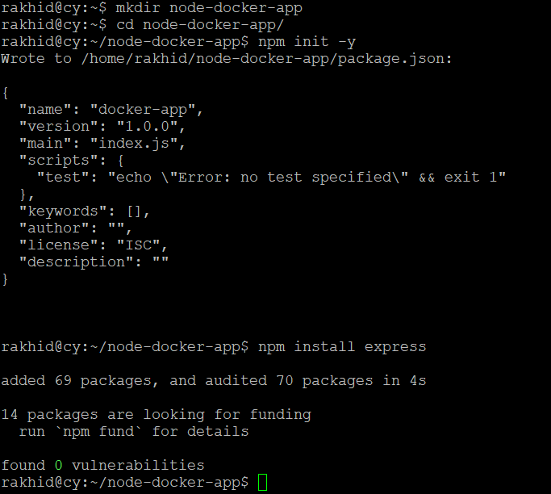
5.create file server.js- nano server.js
const express = require('express');
const app = express();
const PORT = process.env.PORT || 3000;
app.get('/', (req, res) => {
res.send('Hello, World from Docker second node js application- rakhi !');
});
app.listen(PORT, () => {
console.log(`Server is running on http://localhost:${PORT}`);
});
6.create dockerfile - nano Dockerfile
# Use Node.js as base image
FROM node:18
# Set the working directory inside the container
WORKDIR /app
# Copy package.json and install dependencies
COPY package*.json ./
RUN npm install
# Copy the application code
COPY . .
# Expose the application port
EXPOSE 3000
# Command to run the application
CMD ["node", "server.js"]
7. build the docker image – sudo docker build -t node-hello-world .
8. run the container using command- sudo docker run -p 3000:3000 --rm node-hello-world
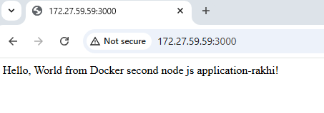
---------- For Python project----------
1. mkdir my-python-app cd my-python-app
2. nano requirements.txt
Flask
3. nano app.py
from flask import Flask
app = Flask(__name__)
@app.route('/')
def hello_world():
return 'Hello, World from Docker!'
if __name__ == '__main__':
app.run(host='0.0.0.0', port=5000)
4. nano dockerfile
# Use Python base image
FROM python:3.9
# Set the working directory inside the container
WORKDIR /app
# Copy the requirements file and install dependencies
COPY requirements.txt .
RUN pip install -r requirements.txt
# Copy the application code
COPY . .
# Expose the application port
EXPOSE 5000
# Command to run the application
CMD ["python", "app.py"]
5. sudo docker build -t python-hello-world .
6. sudo docker run -d -p 5009:5000 python-hello-world
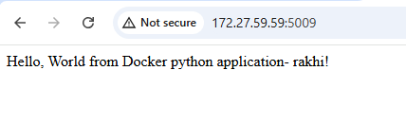
---------- For Angular project----------
1.
npx @angular/cli new angular-docker-app –defaults
2.cd angular-docker-app
3.nano dockerfile
# Stage 1: Build the Angular application
FROM node:18 AS build
WORKDIR /app
COPY package.json package-lock.json ./
RUN npm install
COPY . .
RUN npm run build --configuration=production
# Stage 2: Serve the Angular app using Nginx
FROM nginx:alpine
COPY --from=build /app/dist/angular-docker-app /usr/share/nginx/html
EXPOSE 80
CMD ["nginx", "-g", "daemon off;"]
4.sudo docker build -t angular-container-app
5.rakhid@cy:~/angular-docker-app/angular-docker-app$ sudo docker run -d -p 8080:80 angular-container-app
284f14e334f619ef68e53fca1eb14d3a37c02601bf2534244d6bf0a3d3ec3d1c
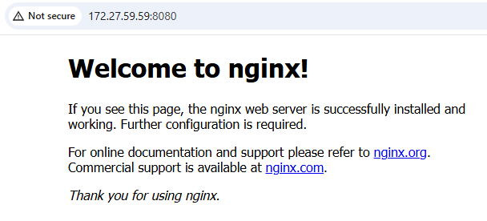
To stop the running container:
docker ps # Get the container ID
docker stop <container_id>

To remove the container:
CopyEdit
docker rm <container_id>

To remove the image:
CopyEdit
docker rmi angular-container-app

rakhid@cy:~/angular-docker-app/angular-docker-app$ sudo docker ps
CONTAINER ID IMAGE COMMAND CREATED STATUS PORTS NAMES
284f14e334f6 angular-container-app "/docker-entrypoint.…" 12 minutes ago Up 12 minutes 0.0.0.0:8080->80/tcp, :::8080->80/tcp nervous_spence
e4d0efb465d5 python-hello-world "python app.py" 2 hours ago Up 2 hours 0.0.0.0:5009->5000/tcp, :::5009->5000/tcp happy_hertz
9718b19e1e86 node-hello-world "docker-entrypoint.s…" 20 hours ago Up 20 hours 0.0.0.0:3000->3000/tcp, :::3000->3000/tcp keen_williams
Poc 3. Docker linking using docker network ---------------------------
Mkdir dockernetworkrakhi
Cd dockernetworkrakhi
rakhid@cy:~/dockernetworkrakhi$ sudo docker network create mynetwork
[sudo] password for rakhid:
0974e74d436095616522097c31e9e322d343ff2a24758a8dbc0f277f1094c13b
rakhid@cy:~/dockernetworkrakhi$ sudo docker run -d --name mongodbrakhi --network mynetwork -p 27017:27017 mongo
a67983922da864b4005bd8e989f93bacafdc79d1745c456bc131cfff210ee459
• -d → Runs the container in detached mode.
• --name mongodb → Names the container mongodbrakhi.
• --network mynetwork → Connects it to the mynetwork.
• -p 27017:27017 → Maps MongoDB’s port 27017 to the host.
mkdir node-mongo-app && cd node-mongo-app
npx init -y
npm install express mongoose
nano index.js
const express = require("express");
const mongoose = require("mongoose");
const app = express();
const PORT = 3000;
const MONGO_URL = "mongodb://mongodb:27017/mydatabase"; // Connects to MongoDB container
mongoose.connect(MONGO_URL, { useNewUrlParser: true, useUnifiedTopology: true })
.then(() => console.log("Connected to MongoDB"))
.catch(err => console.error("MongoDB Connection Error:", err));
app.get("/", (req, res) => {
res.send("Hello from Node.js & MongoDB!");
});
app.listen(PORT, () => {
console.log(`Server running on port ${PORT}`);
});
nano dockerfile
# Use official Node.js image
FROM node:18
# Set working directory
WORKDIR /app
# Copy package.json and install dependencies
COPY package.json ./
RUN npm install
# Copy the rest of the application
COPY . .
# Expose the application port
EXPOSE 3000
# Run the application
CMD ["node", "index.js"]
Sudo docker build -t node-app .
sudo docker run -d --name node-frontend-newrakhi --network mynetwork -p 3000:3000 node-app
sudo docker rm -f node-frontend-newrakhi
sudo docker run -d --name node-frontend-newrakhi --network mynetwork -p 3001:3000 node-app
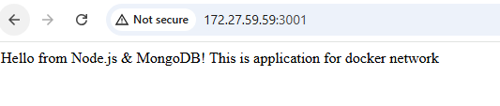
In Docker, linking containers means establishing communication between two or more containers. This is critical when you have a multi-container setup, like a frontend container communicating with a backend or a backend container communicating with a database.
There are multiple ways to link Docker containers, each suited for specific scenarios. Let me break it down in detail:

1. Using Docker Networks (Preferred Way)
Docker networks allow containers to communicate seamlessly by placing them in the same network. This method is preferred over the legacy --link option because it is more flexible and modern.

How it Works:
- Containers connected to the same custom network can communicate using their container names as hostnames.
- Docker automatically manages DNS resolution.

Steps:
- Create a Custom Network:
- docker network create mynetwork
- Run Containers in the Same Network:
- docker run -d --name backend --network mynetwork my-backend-image
- docker run -d --name frontend --network mynetwork -p 3000:3000 my-frontend-image
- Access Other Containers:
  - Inside the frontend container, you can access backend using its container name, like http://backend:8080.

Advantages:
- Simple to set up and manage.
- Allows automatic DNS resolution of container names.
- Supports multiple networks for isolation.

2. Using Docker Compose
Docker Compose simplifies linking containers by defining services in a single docker-compose.yml file. Compose automatically creates a network for all the services and links them together.

How it Works:
- Each service runs in a container, and they can access each other by their service names.

Steps:
- Create docker-compose.yml:
- version: "3.8"
- services:
- backend:
- image: my-backend-image
- networks:
- - app-network

- frontend:
- image: my-frontend-image
- networks:
- - app-network
- ports:
- - "3000:3000"

- networks:
- app-network:
- driver: bridge
- Run the Compose File:
- docker-compose up -d
- Access Other Containers:
  - From frontend, you can access the backend at http://backend:8080.

Advantages:
- Combines container management and linking into one configuration file.
- Automatically manages networks and volumes.

3. Using --link (Legacy Method)
The --link flag was used in earlier versions of Docker to link containers. This method is now deprecated in favor of networks but is still worth knowing.

How it Works:
- Links are established using the --link option when running a container.
- Docker creates environment variables and /etc/hosts entries to allow communication.

Steps:
- Run Backend Container:
- docker run -d --name backend my-backend-image
- Run Frontend Container with a Link to Backend:
- docker run -d --name frontend --link backend:backend -p 3000:3000 my-frontend-image
- Access Linked Containers:
  - Inside the frontend container, you can use http://backend to communicate with the backend.

Disadvantages:
- Limited to single-host setups.
- Not recommended for production as it's being deprecated.

4. Using --network=host (Host Networking Mode)
In this mode, containers share the host machine's network stack, allowing them to communicate as if they were running directly on the host.

How it Works:
- The container uses the host's IP address and ports.
- All ports opened in the container are accessible on the host.

Steps:
- Run Container in Host Networking Mode:
- docker run --network=host my-container-image
- Access Containers:
  - All containers share the same network namespace and can communicate directly through loc alhost.

Disadvantages:
- No isolation between containers.
- Can cause port conflicts on the host.

5. Using External Services (Like Service Discovery Tools)
For larger deployments (e.g., Kubernetes or Docker Swarm), service discovery tools like Consul, etcd, or DNS-based solutions are used.

How it Works:
- A service discovery system maps container names to their IPs dynamically.
- Containers register themselves with the service discovery tool.

Steps:
- Set up a service discovery tool (e.g., Consul).
- Run containers with a service registration script.
- Use the discovery tool to resolve container names to IPs.

Comparison of Methods
Method | Recommended For | Portability | Scalability | Complexity
Docker Networks | Most Use Cases | High | High | Low
Docker Compose | Multi-Service Projects | High | Medium | Low
--link (Legacy) | Legacy Applications | Low | Low | Low
Host Networking | High-Performance Needs | Low | Low | Medium
External Services | Large Distributed Apps | High | High | High

Conclusion
For most scenarios, Docker Networks or Docker Compose is the best choice as they provide simplicity, flexibility, and scalability. Use legacy methods like --link only for older Docker setups. For advanced deployments, service discovery tools or orchestration platforms like Kubernetes are more suitable.

4.Docker volume Management : Attach volume to a db Container. then run same container on another host with volume data mounted and check if data persist

5.Volume mount- Delete mysql container and create new with previous data

Three tier application
mkdir three-tier-app-rakhi
cd three-tier-app-rakhi
project structure-
backend-java 8088, frontend-angular.js 8087, mongodb 27027
three-tier-app/
├── frontend/ # AngularJS frontend
├── backend/ # Java backend
├── database/ # MongoDB initialization
├── docker-compose.yml # Docker Compose configuration
For frontend part-
cd frontend
npm init -y
npm install angular express
nano index.html
<!DOCTYPE html>
<html>
<head>
<title>AngularJS Frontend</title>
<script src="https://ajax.googleapis.com/ajax/libs/angularjs/1.8.2/angular.min.js"></script>
</head>
<body ng-app="myApp">
<h1>Welcome to the Three-Tier App</h1>
<div ng-controller="MainCtrl">
<p>{{ message }}</p>
</div>
<script>
var app = angular.module('myApp', []);
app.controller('MainCtrl', function($scope) {
$scope.message = "26074This is the AngularJS frontend!";
});
</script>
</body>
</html>
Create a server.js file:
nano server.js
const express = require('express');
const path = require('path');
const app = express();
app.use(express.static(path.join(__dirname)));
app.get('/', (req, res) => {
res.sendFile(path.join(__dirname, 'index.html')); });
app.listen(80, () => {
console.log('Frontend server running on port 80'); });
Create Dockerfile in the frontend folder
nano dockerfile
FROM node:16
WORKDIR /app
COPY . /app
RUN npm install
EXPOSE 80
CMD ["node", "server.js"]
Create a Simple Spring Boot Application:
mkdir backend cd backend
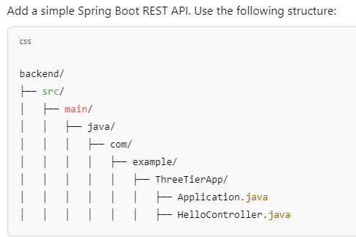
Application.java
package com.example.ThreeTierApp;
import org.springframework.boot.SpringApplication;
import org.springframework.boot.autoconfigure.SpringBootApplication;
@SpringBootApplication
public class Application {
public static void main(String[] args) {
SpringApplication.run(Application.class, args);
} }
HelloController.java
package com.example.ThreeTierApp;
import org.springframework.web.bind.annotation.GetMapping;
import org.springframework.web.bind.annotation.RestController;
@RestController
public class HelloController {
@GetMapping("/api/hello")
public String sayHello() {
return "Hello from the Java Backend!";
}}
Create pom.xml nano pom.xml
<project xmlns="http://maven.apache.org/POM/4.0.0" xmlns:xsi="http://www.w3.org/2001/XMLSchema-instance"
xsi:schemaLocation="http://maven.apache.org/POM/4.0.0 http://maven.apache.org/xsd/maven-4.0.0.xsd">
<modelVersion>4.0.0</modelVersion>
<groupId>com.example</groupId>
<artifactId>three-tier-app-backend</artifactId>
<version>0.0.1-SNAPSHOT</version>
<packaging>jar</packaging>
<name>Three Tier App Backend</name>
<parent>
<groupId>org.springframework.boot</groupId>
<artifactId>spring-boot-starter-parent</artifactId>
<version>2.7.6</version> <!-- Replace this with your desired version -->
<relativePath /> <!-- lookup parent from repository -->
</parent>
<dependencies>
<!-- Spring Boot Starter -->
<dependency>
<groupId>org.springframework.boot</groupId>
<artifactId>spring-boot-starter-web</artifactId>
</dependency>
<!-- MongoDB Starter -->
<dependency>
<groupId>org.springframework.boot</groupId>
<artifactId>spring-boot-starter-data-mongodb</artifactId>
</dependency>
</dependencies>
<build>
<plugins>
<plugin>
<groupId>org.springframework.boot</groupId>
<artifactId>spring-boot-maven-plugin</artifactId>
</plugin>
</plugins>
</build>
</project>
Add a Dockerfile to the backend folder nano Dockerfile
FROM openjdk:17-jdk-slim
WORKDIR /app
COPY target/*.jar app.jar
EXPOSE 8080
ENTRYPOINT ["java", "-jar", "app.jar"]
Create a docker-compose.yml File: In the three-tier-app folder:
nano docker-compose.yml
version: "2.2"
services:
frontend:
build: ./frontend
ports:
- "8087:80"
networks:
- app-network
backend:
build: ./backend
ports:
- "8088:8080"
networks:
- app-network
depends_on:
- database
database:
image: mongo:latest
container_name: mongo-db
volumes:
- db-data:/data/db
ports:
- "27027:27017"
networks:
- app-network
networks:
app-network:
volumes:
db-data:

for running application
sudo docker-compose down
sudo docker-compose build
sudo docker-compose up
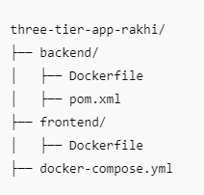

Steps to Run the Application
- Build the Frontend:
cd frontend
npm install
npm run build --prod
- Build the Backend:
cd backend
mvn clean package
- Run Docker Compose:
cd ../
sudo docker-compose down
sudo docker-compose build
sudo docker-compose up --build
sudo docker-compose up

1. GitHub Actions
1.1 Automated workflows with event-based triggers
1.2 Data sharing between jobs, secure secrets management
1.3 Conditional execution and SonarQube integration
1.4 Slack notifications and a complete Java CI pipeline
2. Maven
2.1 Setup, dependency & plugin management
2.2 Configurations, Jacoco code coverage
2.3 Java Spring app build and snapshot creation
3. Docker
3.1 Writing Dockerfiles, building & running containers
3.2 Container linking, volume management & mounting
3.3 CMD overrides, multi-stage builds, and DockerHub pushes
4. Docker Compose & Deployment
4.1 Managing multi-container setups with Docker Compose
4.2 Deploying 3-tier applications and understanding Docker architecture
5. SonarQube
5.1 Setup, CI/CD integration, and static code analysis (Java/Kotlin)
5.2 Reporting and quality gate configuration
6. CI/CD with Jenkins & GitHub Actions
6.1 Automating builds, tests, and deployments for a streamlined DevOps workflow.

Github Actions 1.1 Used variables for efficient workflow management.
1.2 Automated tasks within workflows.
1.3 Used artifacts for data persistence.
1.4 Configured workflows for various GitHub events.
1.5 Managed encrypted secrets securely.
1.6 Controlled job execution dynamically.
1.7 Integrated static code analysis with SonarQube.
1.8 Configured real-time notifications in Slack.
1.9 Set up and tested self-hosted execution.
1.10 Built, tested, and deployed Java projects.
Maven POCs
2.1 Set up Maven for builds and dependencies.
2.2 Initialized, compiled, and packaged a Maven app.
2.3 Added necessary plugins and dependencies.
2.4 Managed project properties efficiently.
2.5 Implemented test coverage analysis with Jacoco.
2.6 Developed and packaged a Spring Boot app.
2.7 Managed snapshot versions.
2.8 Defined modular architecture using a parent-child structure.
2.9 Created interdependent modules in a multi-module project.
2.10 Used dependency inheritance.
Docker POCs
3.1 Containerized Java, Node.js, Python, and Angular apps.
3.2 Packaged and managed Docker images.
3.3 Connected frontend (Node.js) and backend (MongoDB) services.
3.4 Ensured database persistence with Docker volumes.
3.5 Retained MySQL data after container deletion.
3.6 Managed multiple containers efficiently using Docker Compose.
3.7 Modified container entry commands.
3.8 Managed private Docker repositories by pushing images to Docker Hub.
3.9 Optimized Docker builds with multi-stage Docker file.
3.10 Configured environment variables via Docker file and CLI.
3.11 Hosted frontend, backend, and database in a 3-tier application.
3.12 Managed containers on Windows and VirtualBox.
3.13 Analyzed key differences between Docker and VMs.
3.14 Understood container networking with service discovery.
CI/CD Implementations
4.1 Automated build, test, analysis, and deployment using Jenkins & GitHub Actions.
SonarQube
5.1 Installation and Configuration
5.2 Integration with CI/CD Pipelines
5.3 Static Code Analysis for Java and Kotlin Projects
5.4 Reporting and Quality Gate Configuration
CI/CD with Jenkins & GitHub Actions
6.1 Automating builds, tests, and deployments for a streamlined DevOps workflow.
Great question! Let's break it down clearly:

🧾 What is the truncate JSON log command in Docker?
Docker stores container logs in JSON log files by default at this path:
/var/lib/docker/containers/<container-id>/<container-id>-json.log
Over time, these log files can grow large and consume disk space.
To manually clear or reduce the size of these log files without stopping/removing the container, we use the truncate command.

🔧 What is truncate?
truncate is a Linux command used to shrink or extend the size of a file.

🧹 Why use it with Docker logs?
To:
- Free up disk space on production servers.
- Avoid logs growing uncontrollably.
- Clean up logs without removing containers.

📌 How to Use truncate for Docker JSON Logs

✅ Step 1: Find the container ID
docker ps

✅ Step 2: Truncate the JSON log file
sudo truncate -s 0 /var/lib/docker/containers/<container-id>/<container-id>-json.log
📌 Example:
sudo truncate -s 0 /var/lib/docker/containers/abc123456789/abc123456789-json.log
🧹 This will reduce the file size to 0 bytes but not delete the file or container.

⚠️ Important Notes
- You must have root privileges (use sudo).
- This only works if the log driver is json-file (default).
- Best used in combination with log rotation settings in production.

🛡️ How to Prevent Log Growth Automatically
Edit or add /etc/docker/daemon.json:
{
"log-driver": "json-file",
"log-opts": {
"max-size": "10m",
"max-file": "3"
}
}
Then restart Docker:
sudo systemctl restart docker
✅ This will keep only 3 log files, each max 10MB.

📝 DSR Summary Example
✅ Today I worked on Docker log management.
✅ Used truncate -s 0 to clear large Docker JSON log files manually.
✅ Implemented Docker log rotation using daemon.json to auto-limit log file sizes.
🔜 Next, I will explore log drivers like syslog, journald, and central logging with ELK/Prometheus.

Want me to help you write a script to automate log truncation for all containers?

Absolutely! Here's a comprehensive list of Docker commands, organized from basic to advanced, along with short descriptions so you can use them in learning, practice, or your DSR (Daily Status Report).

🐳 Docker Commands from Basic to Advanced

🔰 1. Basic Docker Commands
Command | Description
docker --version | Check installed Docker version
docker info | Show Docker system info
docker help | Show Docker help and command list

📦 2. Docker Image Commands
Command | Description
docker pull <image> | Download an image from Docker Hub
docker images | List all images on local system
docker rmi <image> | Remove an image
docker build -t <name> . | Build image from Dockerfile
docker tag <image> <repo:tag> | Tag an image for pushing
docker push <repo:tag> | Push image to registry (e.g. Docker Hub)

🧱 3. Docker Container Commands
Command | Description
docker run <image> | Run a container
docker run -d <image> | Run in detached mode (background)
docker run -it <image> | Run with interactive terminal
docker ps | List running containers
docker ps -a | List all containers (including stopped)
docker stop <container> | Stop a running container
docker start <container> | Start a stopped container
docker restart <container> | Restart a container
docker rm <container> | Remove a stopped container
docker exec -it <container> bash | Run a command inside a running container
docker logs <container> | View container logs

📂 4. Docker Volume & Mounts
Command | Description
docker volume create <name> | Create a named volume
docker volume ls | List all volumes
docker volume inspect <name> | View volume details
docker volume rm <name> | Remove a volume
-v volume:/path/in/container | Volume mount in docker run
-v /host/path:/container/path | Bind mount in docker run

🌐 5. Docker Networking
Command | Description
docker network ls | List Docker networks
docker network create <name> | Create a user-defined network
docker network inspect <name> | View details of a network
docker network connect <network> <container> | Connect container to network
docker network disconnect <network> <container> | Disconnect container from network

🧰 6. Docker System & Cleanup
Command | Description
docker system df | Show disk usage
docker system prune | Remove unused data (containers, images, etc.)
docker container prune | Remove all stopped containers
docker image prune | Remove unused images
docker volume prune | Remove unused volumes

📜 7. Dockerfile Build Commands
Dockerfile Command | Description
FROM | Base image
RUN | Execute command in build stage
COPY / ADD | Copy files into image
CMD / ENTRYPOINT | Set default command
ENV | Set environment variable
WORKDIR | Set working directory
EXPOSE | Informal port exposure
VOLUME | Create mount point for volume

🐙 8. Docker Compose Commands
Command | Description
docker-compose up | Start services defined in docker-compose.yml
docker-compose down | Stop and remove containers, networks, etc.
docker-compose build | Build or rebuild services
docker-compose ps | List running services
docker-compose logs | Show logs from all services
docker-compose exec <service> bash | Exec into running service

🐝 9. Docker Swarm Commands
Command | Description
docker swarm init | Initialize Swarm
docker swarm join | Join a node to the Swarm
docker node ls | List nodes in Swarm
docker service create | Deploy a service to Swarm
docker service scale <service>=N | Scale service replicas
docker service ls | List services
docker stack deploy -c <file.yml> <stack_name> | Deploy multi-service stack

🧪 10. Advanced Commands / Debugging
Command | Description
docker inspect <object> | View low-level details of image/container
docker stats | Show real-time resource usage
docker top <container> | View running processes inside container
docker diff <container> | Show changes to container's filesystem
docker save / docker load | Save/load image to/from tar archive
docker export / docker import | Export/import container FS as tarball

📌 Bonus: Truncate Docker Log File
sudo truncate -s 0 /var/lib/docker/containers/<container-id>/<container-id>-json.log

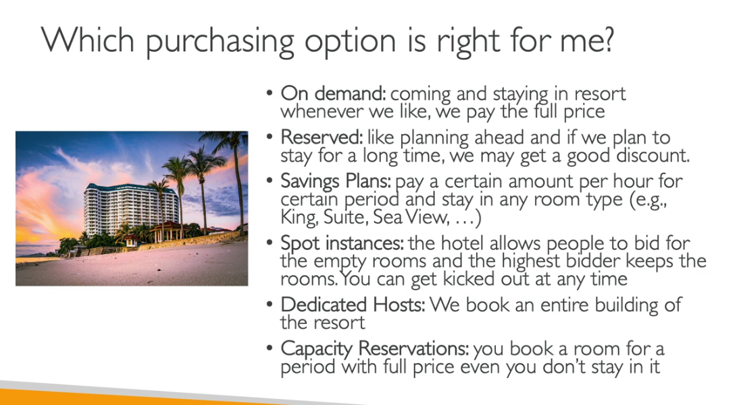
Perfect 👍 you’re asking for a deep dive into Docker CLI commands and all commonly used options like -t, -a, -f, -it, -p, etc.
I’ll explain from basics → intermediate → advanced, with examples and why they’re used (so you don’t just memorize, but actually understand).

🔹 1. Docker Basics
Docker has a few main command groups:
- docker run → Start a new container
- docker ps → List running containers
- docker exec → Run a command inside a container
- docker build → Build an image from a Dockerfile
- docker images → List images
- docker rm, docker rmi → Remove containers/images
- docker logs → View container logs
- docker stop, docker start → Stop/start containers
- docker volume, docker network → Manage data and networking

🔹 2. Common Flags Explained

(A) Interactive / Terminal
- -i → Interactive mode (keeps STDIN open, so you can type into the container).
- -t → Pseudo-TTY (allocates a terminal screen).
- -it = interactive + terminal → Used together for interactive shells.
👉 Example:
docker run -it ubuntu bash
This starts a container with Ubuntu and drops you inside its terminal.

(B) Ports
- -p HOST:CONTAINER → Maps a port on your machine (host) to a port inside the container.
  - First part = your machine’s port
  - Second part = container’s port
👉 Example:
docker run -p 8081:8080 my-spring-app
Now you can open http://localhost:8081 and Docker forwards traffic to the container’s 8080.
- You can map multiple ports:
docker run -p 80:80 -p 443:443 nginx

(C) Detached / Foreground
- By default, containers attach to your terminal (you see logs).
- -d → Detached mode, run in the background.
👉 Example:
docker run -d -p 8080:80 nginx
Runs nginx in background.
Check with:
docker ps

(D) Names & Cleanup
- --name <name> → Give container a name instead of random ID.
- --rm → Remove container automatically when it exits.
- -a → Attach to container (used with docker start -a or docker ps -a).
👉 Example:
docker run --rm --name test-container ubuntu echo "hello world"
Container runs → prints → removed immediately.

(E) Environment Variables
- -e KEY=VALUE → Pass environment variables.
👉 Example:
docker run -e SPRING_PROFILES_ACTIVE=prod my-spring-app

(F) Volumes
- -v HOST_PATH:CONTAINER_PATH → Mounts a folder/file from host to container.
- Keeps data even if the container is deleted.
👉 Example:
docker run -v /home/user/data:/app/data my-image
Files inside /app/data in the container will be stored in /home/user/data on your host.

(G) Force
- -f → Force remove container or image.
👉 Example:
docker rm -f container_id
docker rmi -f image_id

🔹 3. Useful docker Commands with Flags

(A) Run a container
docker run -dit -p 81:3000 --name my-frontend my-react-app
- -d = detached (background)
- -i = interactive
- -t = terminal
- -p 81:3000 = map host 81 → container 3000
- --name = custom container name

(B) List containers
docker ps # running containers
docker ps -a # all containers (even stopped)

(C) Remove containers/images
docker rm <id> # remove a container
docker rm -f <id> # force remove a container
docker rmi <id> # remove an image
docker rmi -f <id> # force remove an image

(D) Logs
docker logs <id> # view logs
docker logs -f <id> # follow logs (like tail -f)

(E) Exec (run command in running container)
docker exec -it <id> bash # open shell inside container
docker exec -it <id> sh # for alpine/light containers

(F) Stop / Start
docker stop <id>
docker start <id>
docker start -a <id> # start and attach (show logs)

(G) Images
docker images # list images
docker build -t myapp:1.0 . # build image with tag
- -t = tag (name:version).

(H) System cleanup
docker system prune # remove stopped containers, unused networks
docker system prune -a # also remove unused images
docker volume prune # remove unused volumes

🔹 4. Quick Examples
✅ Run Nginx in background, on port 8080:
docker run -d -p 8080:80 nginx
✅ Run Ubuntu interactively:
docker run -it ubuntu bash
✅ Run Spring Boot app with environment vars:
docker run -d -p 8081:8080 \
-e SPRING_PROFILES_ACTIVE=prod \
--name springboot-app my-spring-app
✅ Build and tag an image:
docker build -t myapp:v1 .
✅ Remove container forcefully:
docker rm -f springboot-app

🔹 5. Summary of Flags
Flag | Meaning
-i | Interactive (STDIN open)
-t | Allocate a terminal (TTY)
-it | Interactive terminal (for shells)
-d | Detached (background)
-p | Port mapping (host:container)
-v | Volume mount (host:container)
-e | Environment variable
--name | Custom container name
--rm | Auto-remove container on exit
-a | Attach (used with start/logs/ps -a)
-f | Force (remove, delete)
-t (build) | Tag image (name:tag)

👉 Would you like me to also create a one-page cheat sheet (PDF-style) with all these commands, so you can keep it handy while working on EC2/Docker?

Go to folder Product-API-main
# Go to project root (where pom.xml is)
cd ~/myproject

# Build project
mvn clean install -DskipTests

# Run the generated jar (in target folder)
java -jar target/myproject-1.0-SNAPSHOT.jar
sudo docker exec -it mysql-db mysql -u root –p

check login user
sudo docker info | grep Username
sudo docker logout
sudo docker login
username rakhidhomane
password Cybage@12345
sudo docker run -d \
--name mysql-db \
-e MYSQL_ROOT_PASSWORD=rootpassword \
-e MYSQL_DATABASE=productdb \
-e MYSQL_USER=productuser \
-e MYSQL_PASSWORD=productpass \
-p 3306:3306 \
mysql:8.0
rakhid@cy:~/ThreeTierAppProductAPI/ThreeTierAppProductAPI$ sudo docker run -d \
> --name mysql-db \
> -e MYSQL_ROOT_PASSWORD=rootpassword \
> -e MYSQL_DATABASE=productdb \
> -e MYSQL_USER=productuser \
> -e MYSQL_PASSWORD=productpass \
> -p 3306:3306 \
> mysql:8.0
0bed667cea493cae2d724fa486bed82ec811c4ae3f02adf7de21a52db339b06e
rakhid@cy:~/ThreeTierAppProductAPI/ThreeTierAppProductAPI$ sudo docker exec -it mysql-db mysql -u root -p
Enter password:
Welcome to the MySQL monitor. Commands end with ; or \g.
Your MySQL connection id is 8
Server version: 8.0.43 MySQL Community Server - GPL

Copyright (c) 2000, 2025, Oracle and/or its affiliates.

Oracle is a registered trademark of Oracle Corporation and/or its
affiliates. Other names may be trademarks of their respective
owners.

Type 'help;' or '\h' for help. Type '\c' to clear the current input statement.

mysql> show databases;
+--------------------+
| Database |
+--------------------+
| information_schema |
| mysql |
| performance_schema |
| productdb |
| sys |
+--------------------+
5 rows in set (0.00 sec)
mysql> use productdb;
Database changed
mysql> show tables;
Empty set (0.00 sec)

mysql> ^C
mysql> SELECT host, user FROM mysql.user WHERE user = 'productuser';
+------+-------------+
| host | user |
+------+-------------+
| % | productuser |
+------+-------------+
1 row in set (0.03 sec)

mysql> GRANT ALL PRIVILEGES ON productdb.* TO 'productuser'@'%';
Query OK, 0 rows affected (0.10 sec)

mysql> FLUSH PRIVILEGES;
Query OK, 0 rows affected (0.10 sec)
sudo docker exec -it mysql-db mysql -u productuser –p
password-productpass

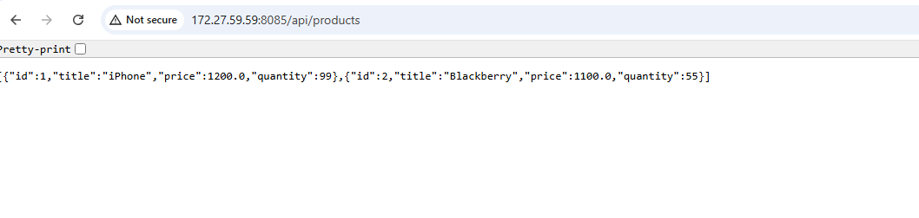
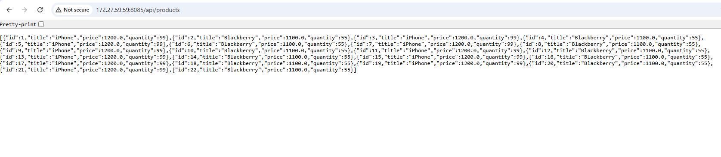
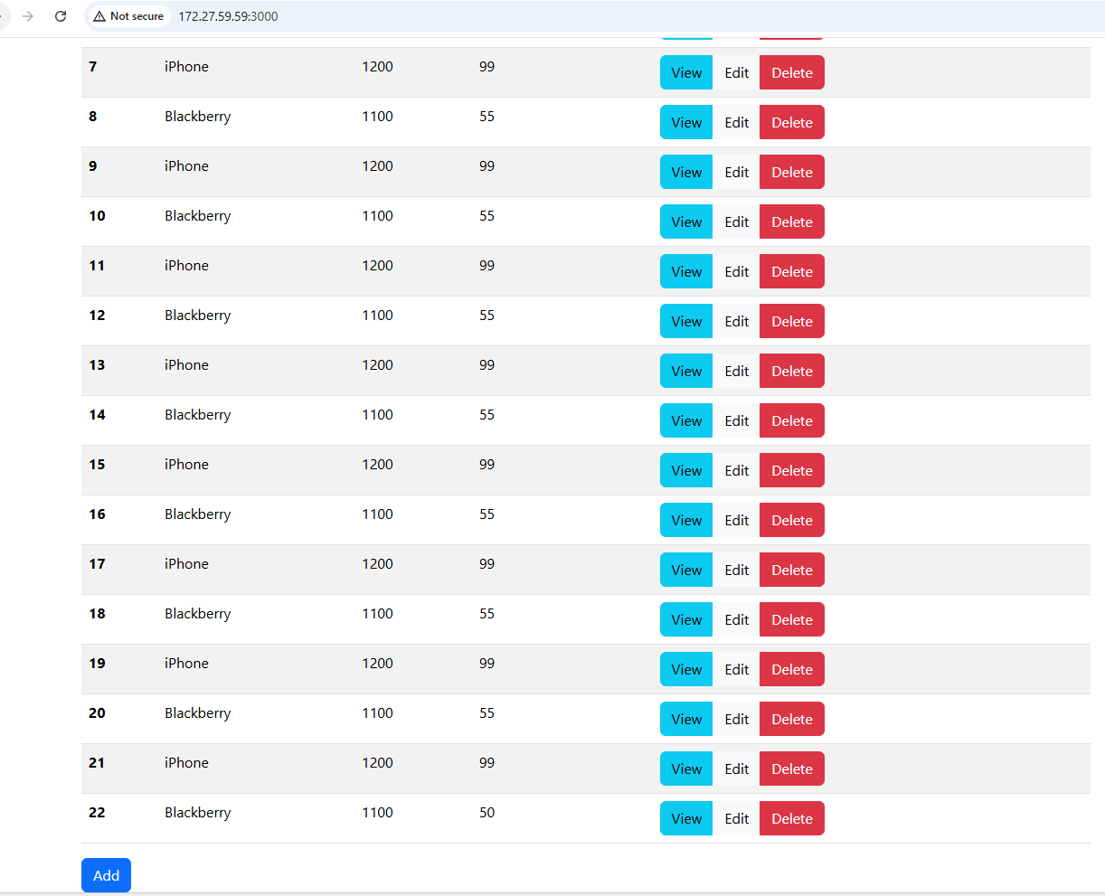
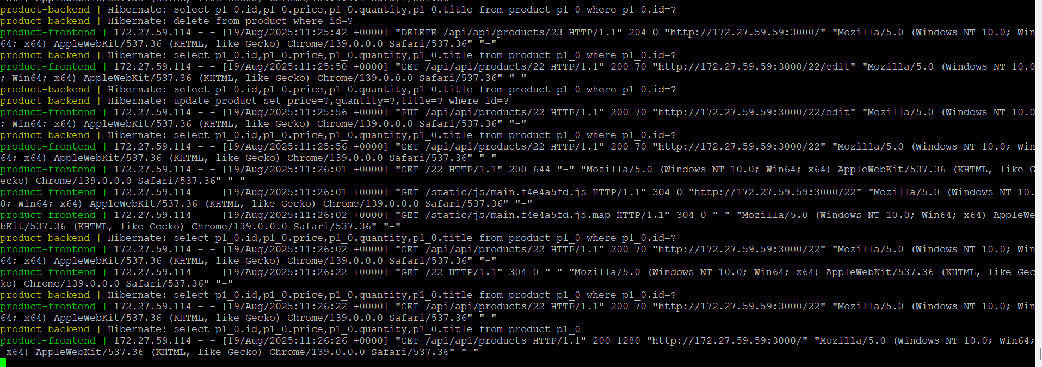

Dockerfile – frontend------------------------
# Step 1: Use Nginx base image
FROM nginx:alpine
# Step 2: Remove default Nginx config
RUN rm /etc/nginx/conf.d/default.conf
# Step 3: Copy your custom config
COPY default.conf /etc/nginx/conf.d/
# Step 4: Copy React build output to Nginx HTML folder
COPY build/ /usr/share/nginx/html/
# Step 5: Expose port
EXPOSE 80
# Step 6: Start Nginx
CMD ["nginx", "-g", "daemon off;"]

Dockerfile-backend -------------------
# Stage 1: Build the application
FROM maven:3.8.4-openjdk-17 AS build
WORKDIR /app
# Copy pom.xml and download dependencies
COPY ./pom.xml /app
RUN mvn dependency:go-offline
# Copy source code and build
COPY ./src /app/src
RUN mvn clean package -DskipTests
# Stage 2: Run the application
FROM openjdk:17-jdk-slim
WORKDIR /app
# Copy jar from build stage
COPY --from=build /app/target/*.jar app.jar
# Run the application
ENTRYPOINT ["java", "-jar", "app.jar"]

Docker compose file-----------------
version: "3.3"

services:
mysql-db:
image: mysql:8.0
container_name: mysql-db
environment:
MYSQL_ROOT_PASSWORD: rootpass
MYSQL_DATABASE: productdb
MYSQL_USER: productuser
MYSQL_PASSWORD: productpass
ports:
- "3306:3306"
volumes:
- mysql_data:/var/lib/mysql
- ./init.sql:/docker-entrypoint-initdb.d/init.sql
networks:
- product-network
healthcheck:
test: ["CMD", "mysqladmin", "ping", "-h", "localhost"]
interval: 10s
retries: 5

backend:
build:
context: ./ProductApp-API-main
container_name: product-backend
depends_on:
- mysql-db
environment:
SPRING_DATASOURCE_URL: jdbc:mysql://mysql-db:3306/productdb?useSSL=true&requireSSL=true&enabledTLSProtocols=TLSv1.2,TLSv1.3&allowPublicKeyRetrieval=true
SPRING_DATASOURCE_USERNAME: productuser
SPRING_DATASOURCE_PASSWORD: productpass
ports:
- "8085:8080"
networks:
- product-network

frontend:
build:
context: ./ProductApp-UI-main
container_name: product-frontend
restart: always
environment:
# Point frontend to backend service (inside docker network)
REACT_APP_API_BASE_URL: http://product-backend:8080
ports:
- "3000:80"
depends_on:
- backend
networks:
- product-network

volumes:
mysql_data:

networks:
product-network:
driver: bridge
name: CI/CD - Build and Push Docker Images

on:
push:
branches:
- main
- dev
- 'feature/*'
- 'release/*'

pull_request:
branches:
- main
- dev

workflow_dispatch: # <-- Enables manual trigger

jobs:
build-and-deploy:
runs-on: ubuntu-latest

steps:
# Step 1: Checkout Code
- name: Checkout source code
uses: actions/checkout@v3

# Step 2: Set up Java
- name: Set up JDK 17
uses: actions/setup-java@v3
with:
java-version: '17'
distribution: 'temurin'

# Step 3: Build Java backend with Maven
- name: Build backend with Maven
working-directory: ./ProductApp-API-main
run: mvn clean package -DskipTests

# Step 4: Install Node.js and build React frontend
- name: Setup Node.js
uses: actions/setup-node@v3
with:
node-version: '18'

- name: Install and build frontend
working-directory: ./ProductApp-UI-main
run: |
npm install --legacy-peer-deps
CI='' npm run build # Disable CI environment so warnings won't be treated as errors

# Step 5: Log in to Docker Hub
- name: Docker login
run: echo "${{ secrets.DOCKERHUB_TOKEN }}" | docker login -u "${{ secrets.DOCKERHUB_USERNAME }}" --password-stdin

# Step 6: Build & push backend image
- name: Build backend Docker image
run: docker build -t ${{ secrets.DOCKERHUB_USERNAME }}/product-backend ./ProductApp-API-main

- name: Push backend image
run: docker push ${{ secrets.DOCKERHUB_USERNAME }}/product-backend

# Step 7: Build & push frontend image
- name: Build frontend Docker image
run: docker build -t ${{ secrets.DOCKERHUB_USERNAME }}/product-frontend ./ProductApp-UI-main

- name: Push frontend image
run: docker push ${{ secrets.DOCKERHUB_USERNAME }}/product-frontend
Great question 🚀 — Trivy is very flexible. In GitHub Actions (or CLI), you can configure conditions to decide when the scan should fail, continue, or just report. Here are the main ones you can use:

🔎 1. Severity Levels
You can filter vulnerabilities by severity:
with:
severity: CRITICAL,HIGH,MEDIUM,LOW
- Options: UNKNOWN, LOW, MEDIUM, HIGH, CRITICAL
- Example: Only fail for CRITICAL and HIGH.

🔎 2. Exit Code Conditions
You can define when the scan should make the pipeline fail:
with:
exit-code: 1
- exit-code: 0 → Never fail, always pass.
- exit-code: 1 → Fail if vulnerabilities found at the specified severity.

🔎 3. Ignore Unfixed Vulnerabilities
Sometimes you don’t want to block builds on vulnerabilities that have no patch:
with:
ignore-unfixed: true

🔎 4. Scanners (What to Scan)
Choose what Trivy scans for:
with:
scanners: vuln,secret,config,license
- vuln → OS packages and libraries
- secret → API keys, credentials
- config → IaC misconfigurations (Dockerfile, Kubernetes, Terraform)
- license → License compliance issues

🔎 5. Exit on Threshold (Fail Only If Count Exceeds)
with:
vuln-type: os,library
severity: CRITICAL,HIGH
exit-code: 1
- Scan both OS packages (apt, yum) and libraries (maven, npm).

🔎 6. Ignore Policies / Custom Rules
You can tell Trivy to ignore vulnerabilities with an .trivyignore file:
CVE-2023-1234
CVE-2022-5678
And in workflow:
with:
ignore-policy: .trivyignore

🔎 7. Output Formats
Control how results are saved:
with:
format: sarif
output: trivy-results.sarif
- Formats: table (default), json, sarif, template.
(SARIF is useful for GitHub Security tab integration.)

🔎 8. Continue on Error
If you want the workflow to continue even on findings:
continue-on-error: true

✅ Example: Only fail for critical issues in backend image, ignore unfixed vulnerabilities, and produce SARIF report:
- name: Scan backend image with Trivy
uses: aquasecurity/trivy-action@master
with:
image-ref: ${{ secrets.DOCKERHUB_USERNAME }}/product-backend
severity: CRITICAL
ignore-unfixed: true
exit-code: 1
format: sarif
output: trivy-report.sarif

👉 Do you want me to update your existing workflow so that:
- Backend fails only for CRITICAL vulnerabilities,
- Frontend allows up to HIGH,
- And both generate a SARIF report you can see in GitHub Security tab?

cd /e/ALMPOClist/New\ folder/EC2S3RDS/ThreeTierApplication/ProductApp-UI-main

# Initialize Git
git init

# Create README if not already present
echo "# ProductApp-UI-main" >> README.md

# Stage and commit
git add .
git commit -m "Initial commit - UI"

# Create main branch
git branch -M main

# Add GitHub remote
git remote add origin https://github.com/rakhidhomane/26074_Product_UI_Main.git

# Push to GitHub
git push -u origin main

# Create develop branch
git checkout -b develop
git push -u origin develop

cd /e/ALMPOClist/New\ folder/EC2S3RDS/ThreeTierApplication/ProductApp-API-main

# Initialize Git
git init

# Create README if not already present
echo "# ProductApp-API-main" >> README.md

# Stage and commit
git add .
git commit -m "Initial commit - API"

# Create main branch
git branch -M main

# Add GitHub remote
git remote add origin https://github.com/rakhidhomane/26074_Product_API_Main.git

# Push to GitHub
git push -u origin main

# Create develop branch
git checkout -b develop
git push -u origin develop

